End Of Term Project:

A Study into the Evolution of Selected Nucleotide Sequences

Due:

Armani Willis
Narasim Banavara

Mercy College

Win/Dos 10
Processing

Table of Contents:

Page 1: Title Page

Page 2: Table of Contents

Page 3: Submission Letter

Page 4: Executive Summary

Page 5: Soft Requirements, Developer Deprecations, Instructions

Page 6: To Do, Key Functions, Methods Used, Not Used, Imports, Hints, Websites, Code Snippets

Page 7: Code Snippets

Page 8: Code Snippets

Page 9: Images

Page 10. Image Links, Research Citations

Mercy College, 555 Broadway, Dobbs Ferry

To: Assessment Manager

Site Address: Same as Above

Dear reviewing party:

This page of this document contains the reasons for the developer of the app described in this paper to be explored as a topic relevant to current developments in its related fields of science, and why it is being submitted as a course requirement for the college courses cisc 371 or cisc 471 of Mercy College. I encourage further work made by qualified professionals of its related fields for these reasons.:

Reason 1: This project has scalibility in terms of its ability to display data for purposes relating to DNA computing. This topic includes the ability to use DNA as a computer, a database, or a programming language. This program is useful for, and can support further research into the exploration of DNA, its presence in nature, and its usefulness as both a theory and as an application.

Reason 2: This project displays novelty. Part of the reason that so much was dedicated in terms of time to this application was that its premises were not only intriguing, but nowhere to be found in places such as github, the play store, or even in research databases. The developer expresses the need to develop such an app as relevant to the fields that it is useful for.

Reason 3: This project displays culpability. Another big reason that this app is being supported for common use it its grasp ability for people that this project may be less useful for. This mostly includes hobbyists who truly see DNA as a programming language, and statisticians whose research involves knowledge of aspects of DNA computation theory.

Reason 4: This project displays multiprocity. This means that it may have applications being its current or intended fields of relevance. Its perceived multiprocity is based on the notion of DNA programming being a new concept, and thus may become a default way to write programs, and would not just be useful for applications related to genetics.

Reason 5: This project displays simplicity, and once the way that this app works is learned, even a layman with only a slight fascination with or knowledge of any type of programming may operate this tool. Such persons may also even gain a sense of enjoyment or satisfaction similar to what one may have of a new gadget or concept. Thus, such devices may enstill a greater fascination or will to learn and develop new and old programming concepts.

A sincere rendition: A. Willis, Mercy College

Executive Summary:

This study aims to highlight the sequencing of genes responsible for important enzymes present in organisms and in evolution. The reason for doing this is to make an attempt at the determination of how structures necessary for bodily function arise and form. This study aims at achieving this realization through the use of mathematical models employing statistics in logic, probability, and calculus to find the most likely reasons that structures are present in the bodies of living beings as they are. For the purposes of this project, only the establishment of the declarational procedures will be discussed.

The declaration of the data began some days before this term started where I was reading into the question as to why genes require 4 bases and not 2. I happened across a simple 1 file app in processing that when I tried actually worked, and I could replicate the results with other data sets. As a way of expressing my fascination and gratitude, I decided to attempt to write new files as an extension and as a means to package the data into a more readable form, so that it can be better viewed and used for inferences of why the sequences of bases are as they are.

This project demonstrates scalability with txt files since for as long as the bases are as a txt file, the file would be parsable by the processing program. This could allow for the resequencing of entire genomes, or just specific enzymes. However, some problems with this is that the data needs to be presented as their bases, and these bases must be in common letters. The new file that was written utilizes strings instead of chars and does not contain spaces.

The problem being addressed by this project is after first acquiring a base pair sequence in .txt, the file provided by an author in processing that is meant to read the txt file simply parses through it. The single file that I found on the internet provides no further insight into what the sequence of letters is, why there are only 4 of them, and why they make the sounds that they do. From using this app, the user would be unable to determine that the txt file contains a sequence of base pairs which are molecules that link up with other respective purines and pyrimidines in groups of 6 called codons. The purpose of these codons is to provide a section of the enzyme that the sequence is supposed to make.

My reaction to this simplicity implied that I needed a programmatic solution for explaining what these letters are for and depicting this sequence in a form of music. After looking up what the base pairs meant, I was supposed to formulate a file that converts these base pair sequences into their respective codons, then another file to designate a tone to each of these new respective codons. The purpose of which would be to first truncate the number of notes in the new musical score, and to give the user a wider range of tones to better get an understanding of sequence sounds like, and how this sound sequence would correspond to the shape of the enzyme.

These new apps would be written in processing, and no, they cannot be in a single file because the new codon file is a separate txt file. This means that if I tried to run everything in a single file, it would make a new txt file every single time, which is redundant. Also, the processing language does not allow for master class instantiation, which provides method calls for each public method. From there, I would hope to begin to make basic statistical inferences into why the sequence exists as it is and how the enzyme contributes to overall function of the life form as a whole.
Software requirements specification:

This project utilizes the more recent version of the notepad app: Notepad++ to visualize, edit, read from, and write new .txt files, which is the bases of how the application is supposed to function.

This project utilizes a new form of java: Processing from the Processing Foundation to write the .pde files that are meant to read from and write to the txt files containing the dna information.

This project was built on the windows 10 operating system, but should be replicable or useable on any platform that can run processing and apps that can write txt files.

Deprecations:

This app was meant as an audiovisual tool. Although I was impressed and fascinated at the useful success of the original program, the third .pde file, which was meant to recognize the codons built by the second pde file does not accurately play their sounds.

The program just plays a static monotone, and I have been trying to fix it by adding spaces between each codon. There is no method in .java, or .pde which does that, so it seems pointless to try to redo the whole thing in java.

The compiler also seems to ignore special characters as well as spaces, and just lists the codons in one enormous heap.

Instructions:

1. Find a txt file of nucleaotide bases from a database; convert the recovered file to .txt if not originally in .txt. Place the .txt file into the dnaplay folder.

2. Open the .txt file, from inside the file, right click, then left click ‘select all’ in the drop down box, then select copy.

3. Open a new file from inside the .txt editor, then select paste. Save this file to the basetocodon folder.
Repeat, then save this copy to the audiocodon folder.

4. In the dnaplay folder, click on dnaplay.pde. (Make sure processing is already downloaded onto your computer.) Insert the full file name of the .txt dna file to line=loadStrings(“”). Click the triangle button at the top of the window.

5. Insert the full name of the intended file into String[]line=loadStrings(“”) in basetocodon.pde. If vasoascodons is already present as intended in that folder, please change the value inside out=createWriter(“”) to any ‘input’.txt that resembles the file in loadstrings. Click the triangle button at the top of the window.

6. A small grey box will appear and disappear. When this happens, click the square button at the top of the window. Open the new file created and see that it displays the corresponding strings of codons deprecated at the stops.

7. Use the instructions in step 3 to copy this file to the audiocodon folder.

8. Insert the name of this file into line3=loadStrings(“”) of the third program if not already there. Press the triangle button at the top of the window. When done running, press the square button at the top of the window.

To Do: Make it not repeat perpetually, make it play each tone individually, add spaces to the receiving file, try to do the whole thing over in java, add graphs, add probability charts, add gui…

Key Functions: sonically sequences the individual bases, converts these bases into their respective codons, ends each line of codons at the next stop codon, sonically sequences the individual codons.

Methods Used: In Processing: setup, draw, char, string, array, list, play, amp, frame rate, if, else, print writer, create writer, load strings, split, join, for, length, parse at, to string, delimit, text, break, replace all.

Methods not used: replace, trim, stack trace, append, +.

Import Extensions: processing.sound.*; java.util.*;

Hints taken from: Processing foundation library, uniarts helsinki art and technology, Ben Fry, fahrradlaus, poersch.

Websites: processing.org, github.com, oracle.com, stackoverflow.com

Code Snippets examples:

Sample 1.

SinOsc sin;String[]line;float freq=400;char curchar='x';
int dex=0;int dexline=0;int linum=0;int letternum=0;

void setup(){size(400,400);fill(255);frameRate(10);textSize(90);textAlign(CENTER,CENTER);
line=loadStrings("AVPR1A-spaces.txt");sin=new SinOsc(this);sin.play();sin.amp(.7);}

void draw(){background(0);

if(dex<line.length){String[]pieces=split(line[dex],'\t');
if(linum<pieces[dexline].length()){char[]chars=pieces[dexline].toCharArray();
if(letternum<chars.length){print(chars[letternum]);
char lettercur=chars[letternum];char letternow=chars[letternum];

if(lettercur=='a'){freq=545.6;}else if(lettercur=='t'){freq=537.8;}
else if(lettercur=='c'){freq=537.8;}else if(lettercur=='g'){freq=550;}else{freq=900;}

Description:

This is part of the first pde file. It declares variables needed for the file, void setup() is used to establish parameters of constraints of the program and are read from void draw(). The block of four lines causes the program to parse the file by char, and print the results in the console window. The last line specifies which sound to play by the char value of ‘lettercur’.

Sample 2:

import java.util.*;

String[]toerase=new String[]
{"ttt","ttc","tta","ttg","cct","ctc","cta","ctg","att","atc","ata","atg","gtt","gtc",
"gta","gtg","tct","tcc","tca","tcg","agt","agc","cct","ccc","cca","ccg","act","acc",
"aca","acg","gct","gcc","gca","gcg","tat","tac","taa","tag","tga","cat","cac","aaa",
"cag","aat","aac","aaa","aag","gat","gac","gaa","gag","tgt","tgc","tgg","cgt","cgc",
"cga","cgg","aga","agg","ggt","ggc","gga","ggg","___"," "};

void setup(){
String[]line=loadStrings("AVPR1A-spaces.txt");PrintWriter out=createWriter("vasoascodons.txt");

String j=join(line,"");
//for(n=0;n<150;n++){//if(dexline==20){out.println('\n');}
//For Phenylalanine "ttt","ttc",
//if((letnow=="ttt")||(letnow=="ttc")){lin1=append(lin1,"F ");}
j=j.replaceAll("ttt","Fa");j=j.replaceAll("ttc","Fb");

This is the top part of the second code file. The // indicates that these lines of code were commented out, and they are skipped by the compiler when the program is running.

String[]toerase was needed to get the compiler to recognize which strings to identify to replace with other strings in the new file.

In void setup(), the append function was not needed, the join method is used to declare the string that replaces the toerase string with the new string in the new file.

The base triplet strings were listed after the codon name to make building the toerase string set easier.

Sample 3:

String j2=join(line3,"");for(n=0;n<j2.length();n++){
//if(letcur=="|") {delay(100);}else
//For Phenylalanine "ttt","ttc",
if(letcur=="Fa"){freq=543.40;break;}else if(letcur=="Fb"){freq=541.53;break;}else
//Leucine "tta","ttg","ctt","ctc","cta","ctg",
if(letcur=="La"){freq=544.13;break;}else if(letcur=="Lb"){freq=545.60;break;}else if(letcur=="Lc"){freq=541.53;break;}else
if(letcur=="Ld"){freq=539.70;break;}else if(letcur=="Le"){freq=542.27;break;}else if(letcur=="Lf"){freq=543.73;break;}else
//Isoleucine "att","atc","ata",
if(letcur=="Ia"){freq=544.13;break;}else if(letcur=="Ib"){freq=542.27;break;}else if(letcur=="Ic"){freq=544.87;break;}else
//Methionine "atg",
if(letcur=="Ma"){freq=546.30;break;}else
//Valine "gtt","gtc","gta","gtg",
if(letcur=="Va"){freq=547.80;break;}else if(letcur=="Vb"){freq=543.73;break;}else
if(letcur=="Vc"){freq=546.30;break;}else if(letcur=="Vd"){freq=547.80;break;}else
//Serine "tct","tcc","tca","tcg","agt","agc",
if(letcur=="Sa"){freq=541.53;break;}else if(letcur=="Sb"){freq=539.70;break;}else if(letcur=="Sc"){freq=542.27;break;}else
if(letcur=="Sd"){freq=543.73;break;}else if(letcur=="Se"){freq=546.33;break;}else

This is a chunk of code from the third file, it defines the sound that each version of the new codons in the file were supposed to make. Notice that this method also required else, which translates the compiler to the next method directly, break, which stops the file from executing a current process, delay, which causes the program to time out for a specified time, and for, which is a condition for adding and tracking the number of methods in its loop.

Images:
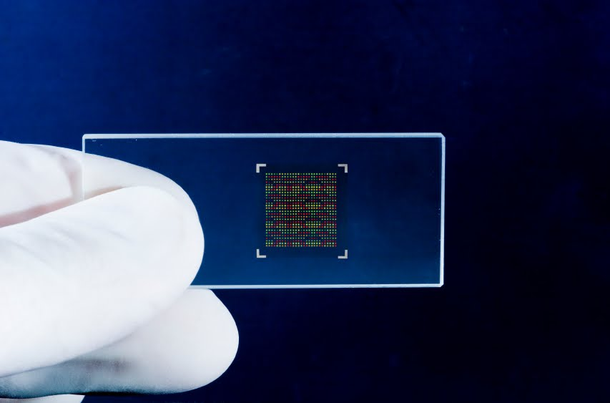
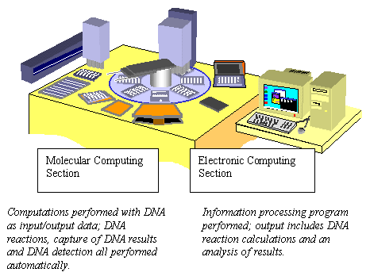
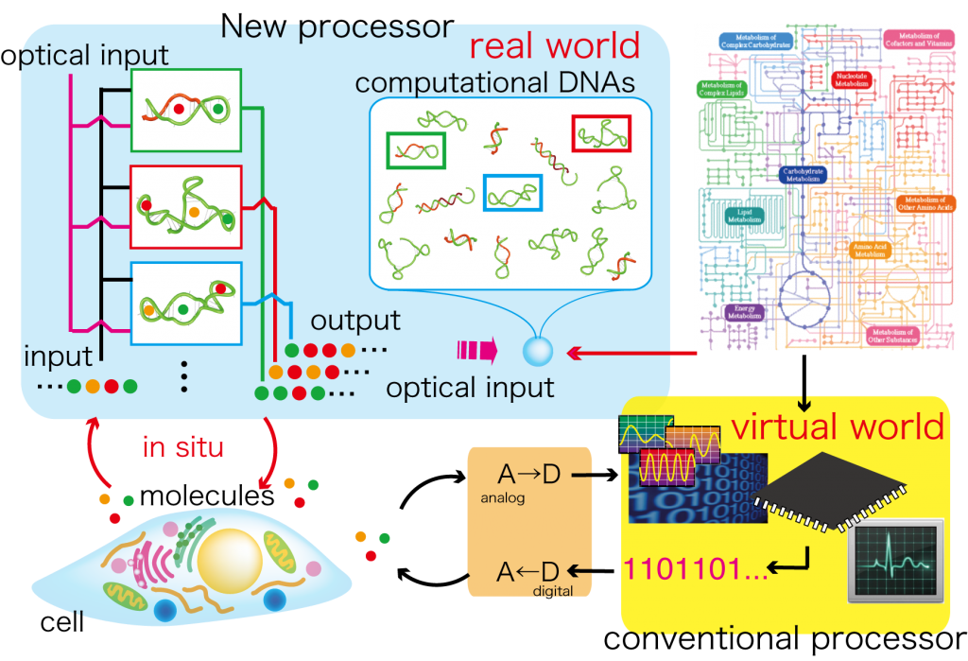
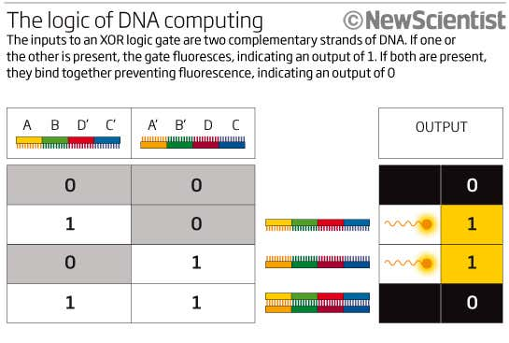

Links And Citations:

Image Links:

https://www.newscientist.com/article/dn18989-dna-logic-gates-herald-injectable-computers/
http://www.geek-officiel.com/stockage-et-traitement-de-donnees-dans-de-ladn
http://rohitpri.blogspot.com/2010/05/dna-computer-computer-made-from-dna-and.html
https://annyfzhang.wordpress.com/2012/09/22/dna-computer-a-significant-step-in-human-history/
https://e-reports-ext.llnl.gov/pdf/752192.pdf
https://yimbyqld.com.au/wp-content/uploads/2016/10/Positive-Submission-Letter-Template_V2-1.png

Research Citations:

Nov, Yuval. Segev, Danny. 2013. Optical Codon Randomization via Mathematical Programming. Department of Statistics, University of Haifa, Israel. Journal of Theoretical Biology. SciVerse ScienceDirect. Elsevier.com/locate/yjtbi.

Pham Tuan, Oconnel, James, Crane, Dennis. 2004. Constrained Codon Optimization by Dynamic Programming. Griffith University, Queensland Australia. Research-repository.griffith.edu.au

Lakin, Matt. Phillips, Andrew. Spacasassi, Andrew. 2018. A Logic Programming Language for Computational Nucleic Acid Devices. University of New Mexico at Albuquerque. ACS Synthetic Biology. Pubs.acs.org/synthbio

Wolf, Ethan. Kim, Peter. 1998. Combinatorial codons: A computer program to approximate amino acid probabilities with biased nucleotide usage. Howard Hughes Medical Institute, Whitehead Institute, Department of Biology, MIT, Nine Cambridge Center, Cambridge, Massachusetts 02142.

Cardelli, Luca. Lakini, Matt. Phillipsi, Andrew. Youssef, Simon. 2011. Abstractions for DNA Circuit Design. Microsoft Research, 7 JJ Thomson Avenue, Cambridge CB3 0FB, UK. Journal of the Royal Society.

